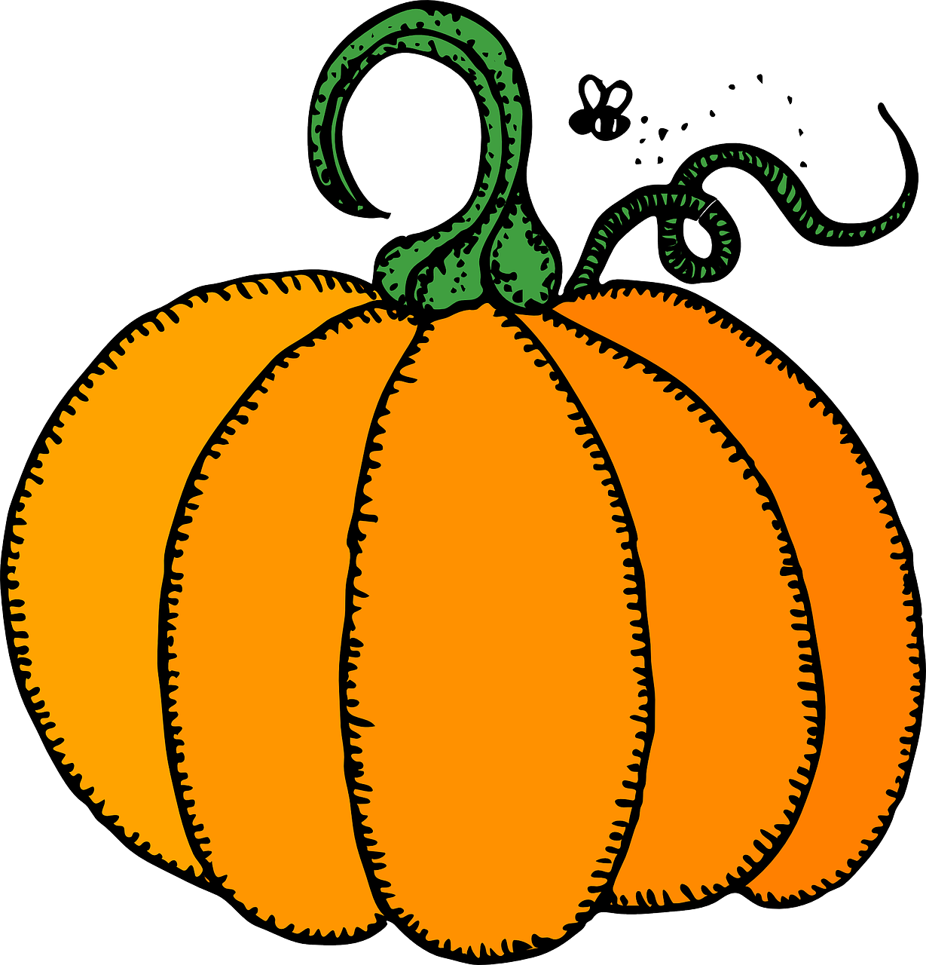
Pumpkin Book Report Project!

Have fun with your realistic fiction book by turning a pumpkin into the main character!

Directions:
- Choose a realistic fiction book

- Read your realistic fiction book at home. Write jots while you are reading. (Some of these will be assigned as homework.) You will hand in 10 jots with the final project.

- Get a pumpkin (any size) and decorate it, so it looks like the main character of your book! (If there is more than one main character in your book, choose one character for this). THERE ARE SOME EXAMPLES AT THE END OF THIS DOCUMENT!

- Fill in the answers to the written part of the book report below.

- Practice your presentation at home so that you are ready to present in class.

Your book report project is due on ________________. Bring your book report and pumpkin into school on this day. We will display your pumpkins on the windowsill in the classroom, and you will present your projects!

Name _____________________________ Class ____ # ___

My Realistic Fiction Book

Title: ________________________________________

Author: ______________________________________

After you are done reading, place TEN jots here. Be sure that they are LEVEL 3 jots, and the page number is on each jot!

Place your TEN jots here! Be sure to tape the top to reinforce them, so they don’t fall off!

Answer the book report questions on the next page!

Book Report Questions

- Who is on your pumpkin? Why did you choose this character?

_____________________________________________________________

_____________________________________________________________

_____________________________________________________________

_____________________________________________________________

_____________________________________________________________

_____________________________________________________________

- What are some things this character did in the story?

_____________________________________________________________

_____________________________________________________________

_____________________________________________________________

_____________________________________________________________

_____________________________________________________________

_____________________________________________________________

_____________________________________________________________

- Do you like this character? Why or why not?

_____________________________________________________________

_____________________________________________________________

_____________________________________________________________

_____________________________________________________________

_____________________________________________________________

_____________________________________________________________

Presentation

This is an example of what to say in your presentation to the class. All of the points in this example should be used. You do not have to memorize this, it is just here to help you!

I read the book ______ by _____. In this story, ____(the main character) does ___(two things that they do in the story). My pumpkin has ____ (describe your pumpkin). I made my pumpkin like this because ________. I would/would not recommend this book because __________.

Example Pumpkin Projects:

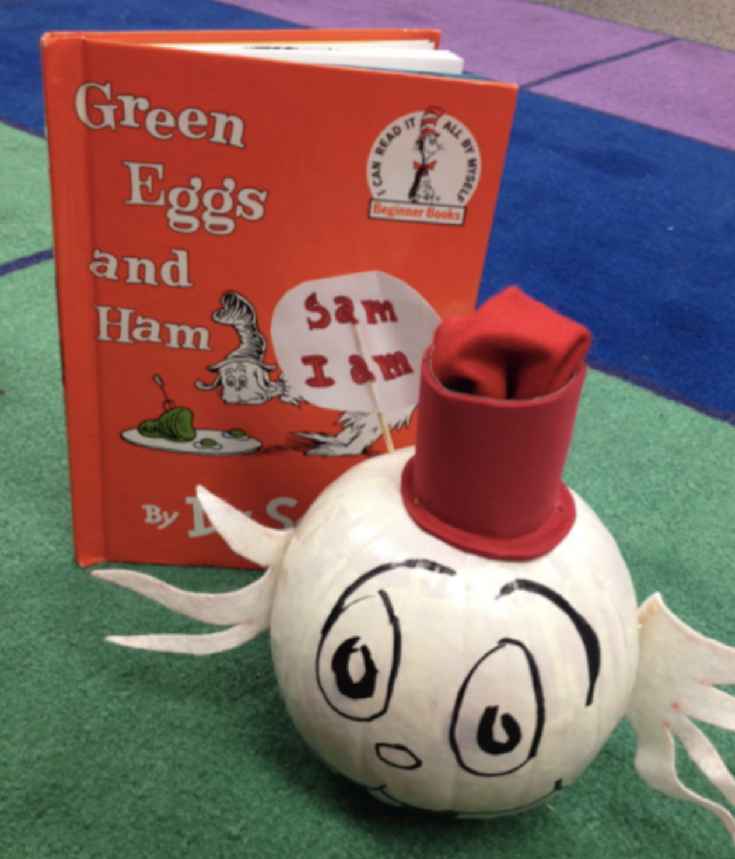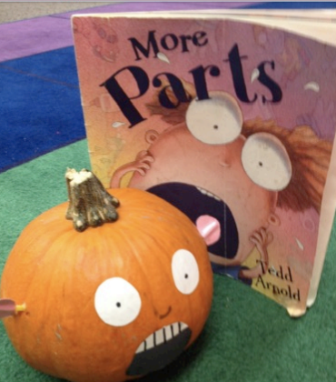

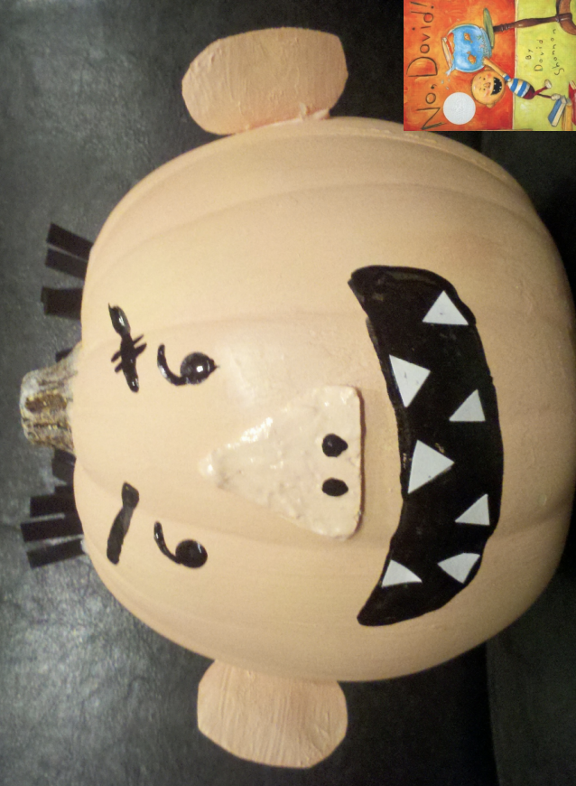

Grading Rubric:

Category | 3 | 2 | 1
Pumpkin | Student clearly put a lot of effort into creating their pumpkin. The pumpkin is creative and represents the character chosen. | Student put effort into the pumpkin. The pumpkin is creative and somewhat represents the character chosen. | Student put minimal effort into their pumpkin. The pumpkin is not well-decorated and does not represent the character chosen.
Jots | Jots contain accurate details and evidence from the text. Student thought deeply and showed deep understanding. Page numbers are used. All 10 jots were handed in. | Jots contain some details but do not have a complete explanation or text evidence. Page numbers are used. Some jots may be missing. | Jots do not show much understanding or effort. They are very basic with no explanation or evidence. Page numbers are not used. May be missing 5 or more jots.
Questions | Student completely and thoroughly answered each question using complete sentences. 4th grade level grammar and spelling was used. | Student answered each question in complete sentences. Some punctuation/spelling errors were made. | Student did not answer every question or did not use complete sentences. Many spelling/punctuation errors were made.
Presentation | The student speaks loudly, clearly, and with expression. The student makes eye contact for the majority of the presentation. The pumpkin is brought in on the day of the presentation. | The student has some difficulty speaking loudly, clearly, and with expression. The student makes eye contact for part of the presentation. The pumpkin is brought in on the day of the presentation. | The student does not speak loudly, clearly, and with expression. The student does not make eye contact for the majority of the presentation. The pumpkin is not brought in on the day of the presentation.

